Go comet testing Assignment

Name: Neel Joshi

1. View list of products

When user clicks on categories, he should see list of products

* Feature file code:

Feature: viewing product list

Scenario: clicking on product categories

Given user must be on homepage by clicking on URL “<https://www.demoblaze.com/index.html>”

When user clicks on category

Then list of products should be displayed

* Step definition java file:

package steps;

import org.openqa.selenium.By;

import org.openqa.selenium.WebDriver;

import org.openqa.selenium.chrome.ChromeDriver;

import io.cucumber.java.en.Given;

import io.cucumber.java.en.Then;

import io.cucumber.java.en.When;

import junit.framework.Assert;

public class StepDefinition {

WebDriver driver;

@Given("user must be on homepage by clicking on url {string}")

public void user_must_be_on_homepage_by_clicking_on_url(String string) {

System.setProperty("webdriver.chrome.driver", "chromedriver.exe");

driver = new ChromeDriver();

driver.get(string);

throw new io.cucumber.java.PendingException();

}

@When("user clicks on mobile phones category")

public void user_clicks_on_mobile_phones_category() {

driver.findElement(By.id("cat")).click();

throw new io.cucumber.java.PendingException();

}

@Then("list of mobile phones should be displayed")

public void list_of_mobile_phones_should_be_displayed() {

boolean actual = driver.findElement(By.cssSelector("html")).isDisplayed();

Assert.assertEquals(true, actual);

throw new io.cucumber.java.PendingException();

}

}

1. View Product Details
2. Add product to cart

* Feature File code:

Feature: Add to cart

Scenario: clicking on Add to cart button should add product to cart

Given user must be on page by clicking URL “<https://www.demoblaze.com/prod.html?idp_=1>”

When user clicks on add to cart button

Then product added to cart dialog box should appear

* Step definition java code:

package steps;

import org.openqa.selenium.chrome.ChromeDriver;

import org.openqa.selenium.By;

import org.openqa.selenium.WebDriver;

import java.util.concurrent.TimeUnit;

import io.cucumber.java.en.Given;

import io.cucumber.java.en.Then;

import io.cucumber.java.en.When;

public class StepDefinition {

WebDriver driver;

@Given("user must be on page by clicking url {string}")

public void user_must_be_on_page_by_clicking_url(String string) {

System.setProperty("webdriver.chrome.driver", "chromedriver.exe");

driver = new ChromeDriver();

driver.get(string);

}

@When("user clicks on add to cart button")

public void user_clicks_on_add_to_cart_button() {

driver.manage().timeouts().implicitlyWait(5, TimeUnit.SECONDS);

driver.findElement(By.xpath("//*[@id=\"tbodyid\"]/div[2]/div/a")).click();

}

@Then("product added to cart dialog box should appear")

public void product_added_to_cart_dialog_box_should_appear() {

driver.manage().timeouts().implicitlyWait(5, TimeUnit.SECONDS);

driver.manage().timeouts().implicitlyWait(5, TimeUnit.SECONDS);

driver.switchTo().alert().accept();

}

}

Screenshot of test execution:

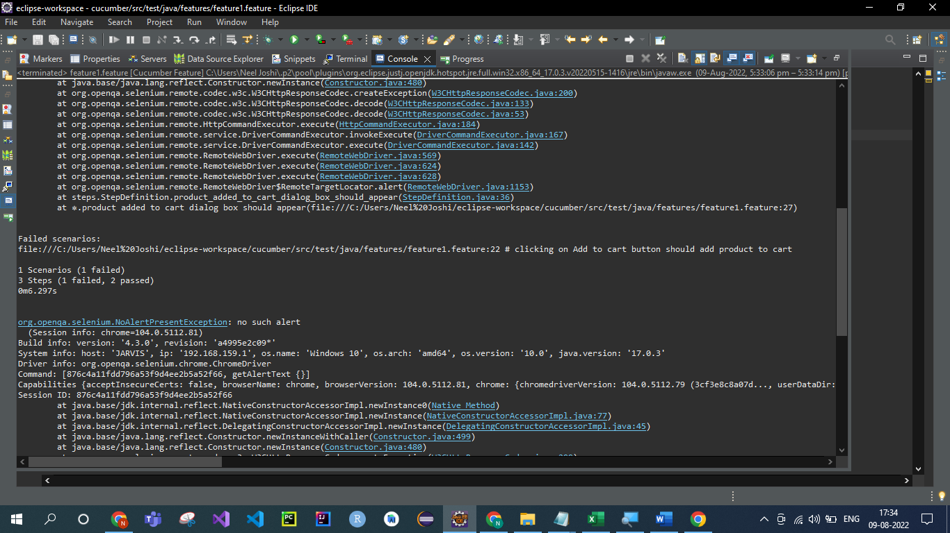

1. Check out and Buy product

* Feature File Code:

Feature: Add to cart

Scenario: clicking on Add to cart button should add product to cart

Given user must be on page by clicking URL <https://www.demoblaze.com/prod.html?idp_=1>

When user clicks on add to cart button

Then product added to cart dialog box should appear

And user should click on cart button to checkout

* Step definition java code:

package steps;

import org.openqa.selenium.chrome.ChromeDriver;

import org.openqa.selenium.support.ui.ExpectedConditions;

import org.openqa.selenium.support.ui.WebDriverWait;

import org.openqa.selenium.Alert;

import org.openqa.selenium.By;

import org.openqa.selenium.WebDriver;

import java.util.concurrent.TimeUnit;

import io.cucumber.java.en.Given;

import io.cucumber.java.en.Then;

import io.cucumber.java.en.When;

public class StepDefinition {

WebDriver driver;

WebDriverWait wait;

Alert alert;

@Given("user must be on page by clicking url {string}")

public void user_must_be_on_page_by_clicking_url(String string) {

System.setProperty("webdriver.chrome.driver", "chromedriver.exe");

driver = new ChromeDriver();

driver.get(string);

}

@When("user clicks on add to cart button")

public void user_clicks_on_add_to_cart_button() {

driver.manage().timeouts().implicitlyWait(5, TimeUnit.SECONDS);

driver.findElement(By.xpath("//*[@id=\"tbodyid\"]/div[2]/div/a")).click(); //ADD TO CART

driver.manage().timeouts().implicitlyWait(5, TimeUnit.SECONDS);

}

@Then("product added to cart dialog box should appear")

public void product_added_to_cart_dialog_box_should_appear() {

//ACCEPT PRODUCT ADDED TO CART ALERT BOX

wait = new WebDriverWait(driver, java.time.Duration.ofSeconds(5));

alert = wait.until(ExpectedConditions.alertIsPresent());

alert.accept();

//driver.switchTo().alert().accept(); PRODUCT ADDED DIALOG

}

@Then("user should click on cart button to checkout")

public void user_should_click_on_cart_button_to_checkout() {

driver.findElement(By.id("cartur")).click(); //CART BUTTON

driver.findElement(By.xpath("//*[@id=\"page-wrapper\"]/div/div[2]/button")).click(); //PLACE ORDER BUTTON

driver.findElement(By.id("name")).sendKeys("ABCD");

driver.findElement(By.id("country")).sendKeys("India");

driver.findElement(By.id("city")).sendKeys("Mumbai");

driver.findElement(By.id("card")).sendKeys("0000");

driver.findElement(By.id("month")).sendKeys("August");

driver.findElement(By.id("year")).sendKeys("2022");

driver.findElement(By.xpath("//*[@id=\"orderModal\"]/div/div/div[3]/button[2]")).click(); //PURCHASE BUTTON

driver.findElement(By.xpath("/html/body/div[10]/div[7]/div/button")).click(); //THANK YOU FOR PURCHASE BUTTON

driver.close();

}

}

